Horizontal Ray
# Source: AI Source: Provided by: [Data Path: Persons Table -> ID Column: 1, Name_En Column: Motasem Essam] -> From: [ChatGPT] on [7/25/2026]
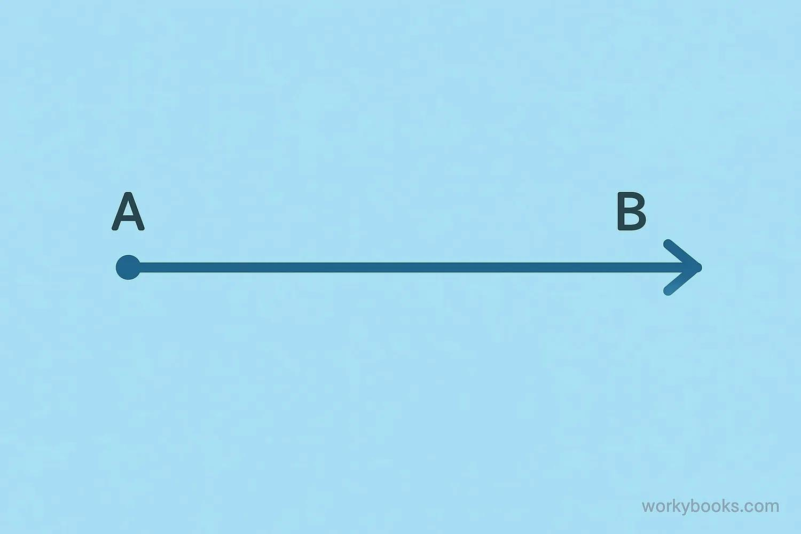
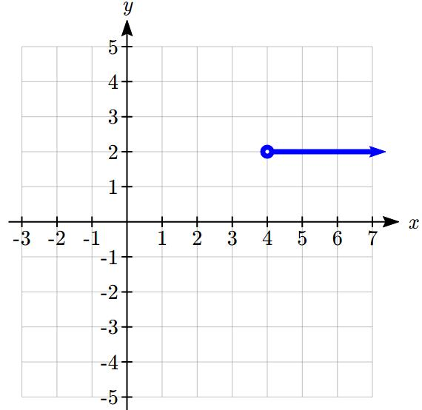
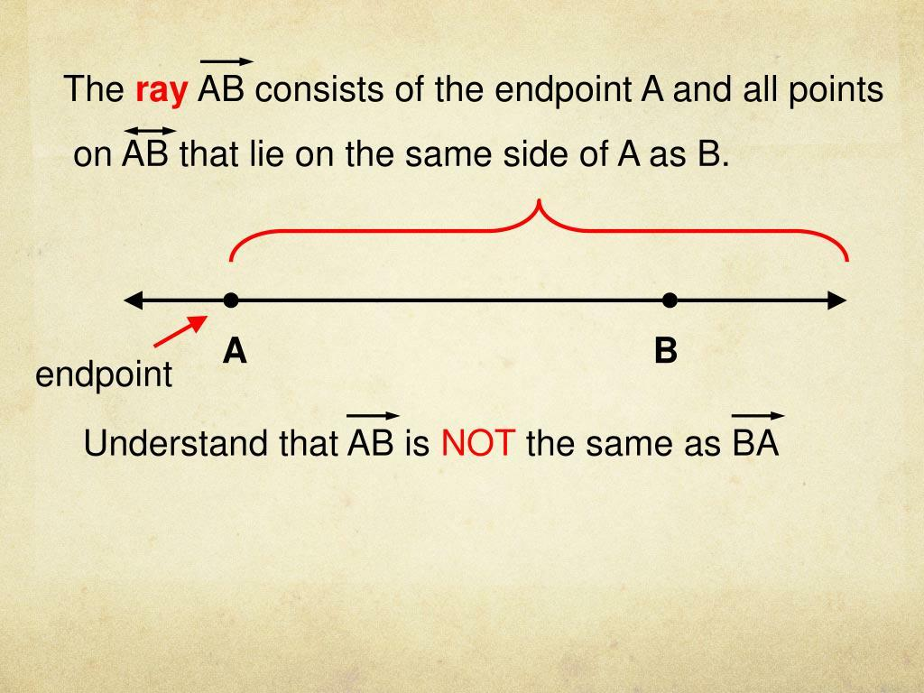
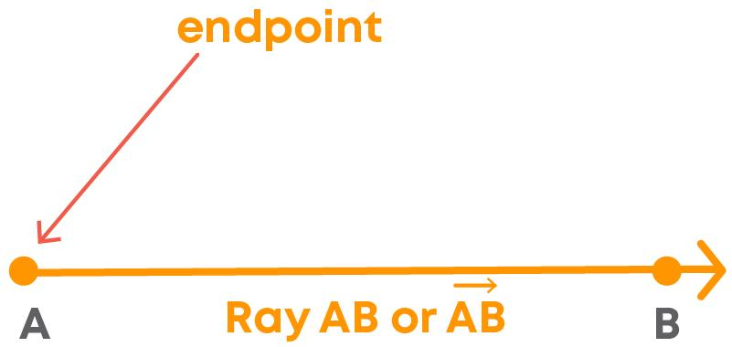

Definition
# Source: AI Source: Provided by: [Data Path: Persons Table -> ID Column: 1, Name_En Column: Motasem Essam] -> From: [ChatGPT] on [7/25/2026]
A Horizontal Ray is a ray that extends horizontally in one direction from a fixed endpoint. It is parallel to the x-axis and has a constant y-coordinate throughout its length.
Unlike a horizontal line or horizontal line segment, a horizontal ray has one endpoint and extends infinitely in only one direction.

Characteristics
# Source: AI Source: Provided by: [Data Path: Persons Table -> ID Column: 1, Name_En Column: Motasem Essam] -> From: [ChatGPT] on [7/25/2026]
A horizontal ray:
- Has one endpoint.
- Extends infinitely in one direction.
- Is parallel to the x-axis.
- Has a constant y-coordinate.
- Has a slope of 0.
- May extend to the left or to the right.

Illustration
# Source: AI Source: Provided by: [Data Path: Persons Table -> ID Column: 1, Name_En Column: Motasem Essam] -> From: [ChatGPT] on [7/25/2026]
Rightward Horizontal Ray
A ●──────────────→

Leftward Horizontal Ray
←──────────────● A

Coordinate Geometry
# Source: AI Source: Provided by: [Data Path: Persons Table -> ID Column: 1, Name_En Column: Motasem Essam] -> From: [ChatGPT] on [7/25/2026]
A horizontal ray begins at:
$$A\left(x_{0} , y\right)$$
and extends infinitely while keeping the same y-coordinate.

Rightward Ray
Starts at:
$$A\left(2 , 5\right)$$
and extends toward increasing x-values.
All points satisfy:
$$x≥2, y=5$$

Leftward Ray
Starts at:
$$A\left(7 , 5\right)$$
and extends toward decreasing x-values.
All points satisfy:
$$x≤7, y=5$$

Slope
The slope of a horizontal ray is:
$$m=0$$
because there is no vertical change.

Examples
# Source: AI Source: Provided by: [Data Path: Persons Table -> ID Column: 1, Name_En Column: Motasem Essam] -> From: [ChatGPT] on [7/25/2026]
Examples of horizontal rays include:
- A laser beam projected horizontally.
- A flashlight beam aimed straight ahead.
- A road extending from a starting point.
- A horizontal arrow in a diagram.
- A one-way horizontal path.

Properties
# Source: AI Source: Provided by: [Data Path: Persons Table -> ID Column: 1, Name_En Column: Motasem Essam] -> From: [ChatGPT] on [7/25/2026]
A horizontal ray:
- Has one endpoint.
- Extends infinitely in one direction.
- Has a constant y-coordinate.
- Has slope equal to zero.
- Is parallel to the x-axis.

Applications
# Source: AI Source: Provided by: [Data Path: Persons Table -> ID Column: 1, Name_En Column: Motasem Essam] -> From: [ChatGPT] on [7/25/2026]
Horizontal rays are used in:
- Plane Geometry
- Coordinate Geometry
- Engineering
- Architecture
- Construction
- Surveying
- CAD (Computer-Aided Design)
- Technical Drawing
- Computer Graphics
- Robotics

Advantages
# Source: AI Source: Provided by: [Data Path: Persons Table -> ID Column: 1, Name_En Column: Motasem Essam] -> From: [ChatGPT] on [7/25/2026]
Studying horizontal rays helps to:
- Understand directed geometric objects.
- Model one-way directions.
- Analyze coordinate systems.
- Construct geometric figures.
- Represent directional movement.

Limitations
# Source: AI Source: Provided by: [Data Path: Persons Table -> ID Column: 1, Name_En Column: Motasem Essam] -> From: [ChatGPT] on [7/25/2026]
A horizontal ray:
- Extends in only one direction.
- Represents only horizontal orientation.
- Has only one endpoint.

Comparison with Related Objects
# Source: AI Source: Provided by: [Data Path: Persons Table -> ID Column: 1, Name_En Column: Motasem Essam] -> From: [ChatGPT] on [7/25/2026]
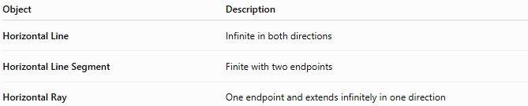
Object | Description
Horizontal Line | Infinite in both directions
Horizontal Line Segment | Finite with two endpoints
Horizontal Ray | One endpoint and extends infinitely in one direction

Key Points
# Source: AI Source: Provided by: [Data Path: Persons Table -> ID Column: 1, Name_En Column: Motasem Essam] -> From: [ChatGPT] on [7/25/2026]
- A Horizontal Ray has one endpoint.
- It extends infinitely in one horizontal direction.
- All points have the same y-coordinate.
- Its slope is:
$$m=0$$
- It is parallel to the x-axis.
- Horizontal rays are widely used in geometry, engineering, architecture, surveying, CAD, technical drawing, and computer graphics.

Conclusion
# Source: AI Source: Provided by: [Data Path: Persons Table -> ID Column: 1, Name_En Column: Motasem Essam] -> From: [ChatGPT] on [7/25/2026]
A Horizontal Ray is a geometric figure that begins at a fixed endpoint and extends infinitely in one horizontal direction while maintaining a constant vertical position. It is parallel to the x-axis, has a slope of zero, and represents directed horizontal movement. Horizontal rays are fundamental in plane geometry, coordinate geometry, engineering, architecture, construction, surveying, CAD, technical drawing, robotics, and computer graphics, where they are used to model directional paths, reference lines, and one-way geometric relationships.

